Lesson No. 2

Levels of Language

Topic 7: What is Language?

The connection between language and literacy is powerful. Some language and literacy learning happens naturally during play and everyday experiences, and some depends on clear instructions from observant and sensitive adults. Language and literacy are connected from infancy onward. Speaking, listening, reading, and writing develop concurrently (together) rather than sequentially (one after the other).

•
Language is a system of communication using sounds or symbols that enables us to
express our feelings, thoughts, ideas and experiences.

- Language is the key to communication.

- The basic purpose of the system of language is communication. It means whenever we have to communicate with others, we have to use language in one or other way.

- Purposes, modes or styles of communication can be different, e.g. chit-chat with a friend, talking with teacher, reading a philosophy book, writing a story, etc. Nevertheless, in each case, a system of language is used.

Topic 8: Different Levels of Language

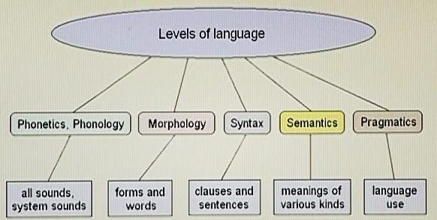

1)
The first level of language is Phonology which is related with sound
- Next, Morphology, is the level of words and forms in language. It is what one normally understands by grammar (along with syntax).
It involves
3) Syntax comes next and is related with clauses, phrases, and sentences.
differences in meaning that occur by changes in word order
4) Semantics is the area of meaning.
5) Pragmatics is the last and is related with use of language

  - All languages are known as systems of communication.
  - The systems of languages may be different from each other but they follow the same levels that start from the basic one (phonology) and go up to use of language (pragmatics).
  - When we study language scientifically in stages like above, it is known as “linguistics”

Extra Reading – Short Note

Linguistics is the scientific study of language. There are three aspects to this study: language
form, language meaning, and language in context

Topic 9: Phonology

Phonology is the study of how sounds are organized and used in natural languages. It is a branch of linguistics concerned with the systematic organization of sounds in languages. The phonological system of a language includes a list of sounds and their features, and rules which specify how sounds interact with each other.

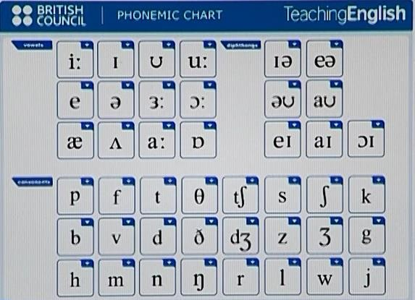
Sounds are represented by signs or symbols in a language, as in this chart which represents sounds in English language. It is called the “International Phonemic Chart of English”. There are 26 alphabets in English and 44 sounds related with those alphabets. These sounds help us to know the exact pronunciation of particular alphabets.

Phonology, therefore, is the study of sounds, and the combination of sounds, that is, how are these sounds organized.
- Sounds are known as “phonemes”

Topic 10: Morphology

Morphology is a sub-discipline of linguistics in which forms and structure of words in a language are studied. In easier words, one can say that sounds combine to form words, and that is Morphology.
Morphology is the study of how things are put together, like the make-up of animals and plants, or the branch of linguistics that studies the structure of words.
In morphology, the word part morph- means "form" and -ology means "the study of." So, those who study how something is made or formed are engaged in morphology. In biology, the morphology of fish might investigate how the gills work as part of the respiratory system. In language morphology, you might study how prefixes and suffixes added to a word change its meaning.
- Words in a language consist of one element, or elements, of meaning which are known as “morphemes”
- Number of “phonemes” (sounds) combines to give a “morpheme” (word).




Topic 11: Syntax

Syntax is the sequence in which words are put together to form sentences. In English, the usual sequence is subject, verb, and object. (Note: Syntactic languages, such as English, use word order to indicate word relationships).
- “Syntax” is a Greek word, which means “order”  
- If words are not put together in certain order in sentence, they will just be morphemes and will not form a proper sentence to convey any meaningful message
- To understand a sentence, a proper order, or sequence of words is necessary. This order or sequence is called Syntax.
- Word arrangement is essential to communicate properly

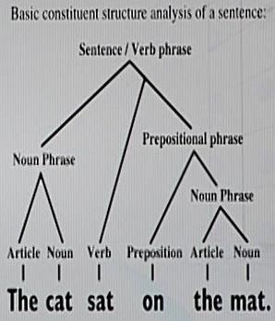



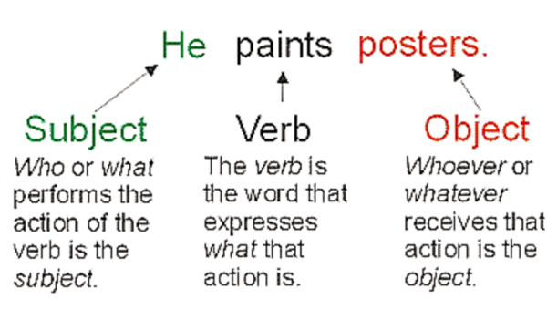
Verb
Subject Object

Topic 12: Semantics and Pragmatics

- Whenever we enter the sphere of “meaning”, we are talking about “semantics” and “pragmatics”.
- “Meaning” is what we use the language for—to communicate with each other, to convey 'what we mean' effectively.
- Both semantics and pragmatics have to do with the meaning of language, and link language to the world.

The branch of linguistics and logic concerned with meaning. It is concerned with the meaning of a word, phrase or text. Similarly, analysis of word meanings and relations between them is also studied here.

Extra Reading SEMANTICS
The most general definition of semantics is that it is "the study of linguistic meaning", or "the study of the meaning of words and sentences"

PRAGMATICS

Pragmatics is the study of "how to do things with words", or "the study of the contribution of context to meaning".

